**Motherboard**

**&**

**CPU**

BASIC COMPUTER USAGE

**OBJECTIVES FOR TODAY** 

* What is **Motherboard**
* Components that connected to Motherboard ✓ What is **CPU?**
* How does CPU work?

**Computer Hardware**

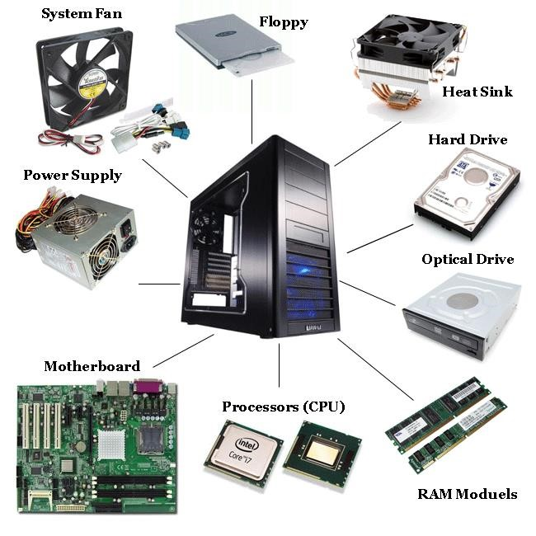 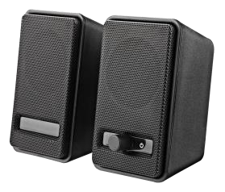 **Speaker**

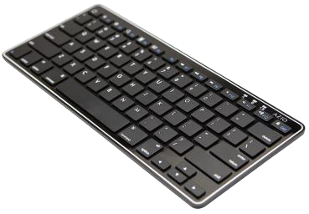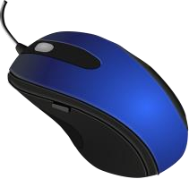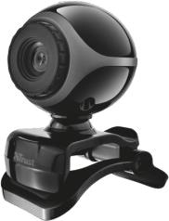

**Monitor**

**Keyboard**

**Webcam Mouse**

EXPLORE

5 MIN **WHAT IS …?**



**Power supply**



**Motherboard**

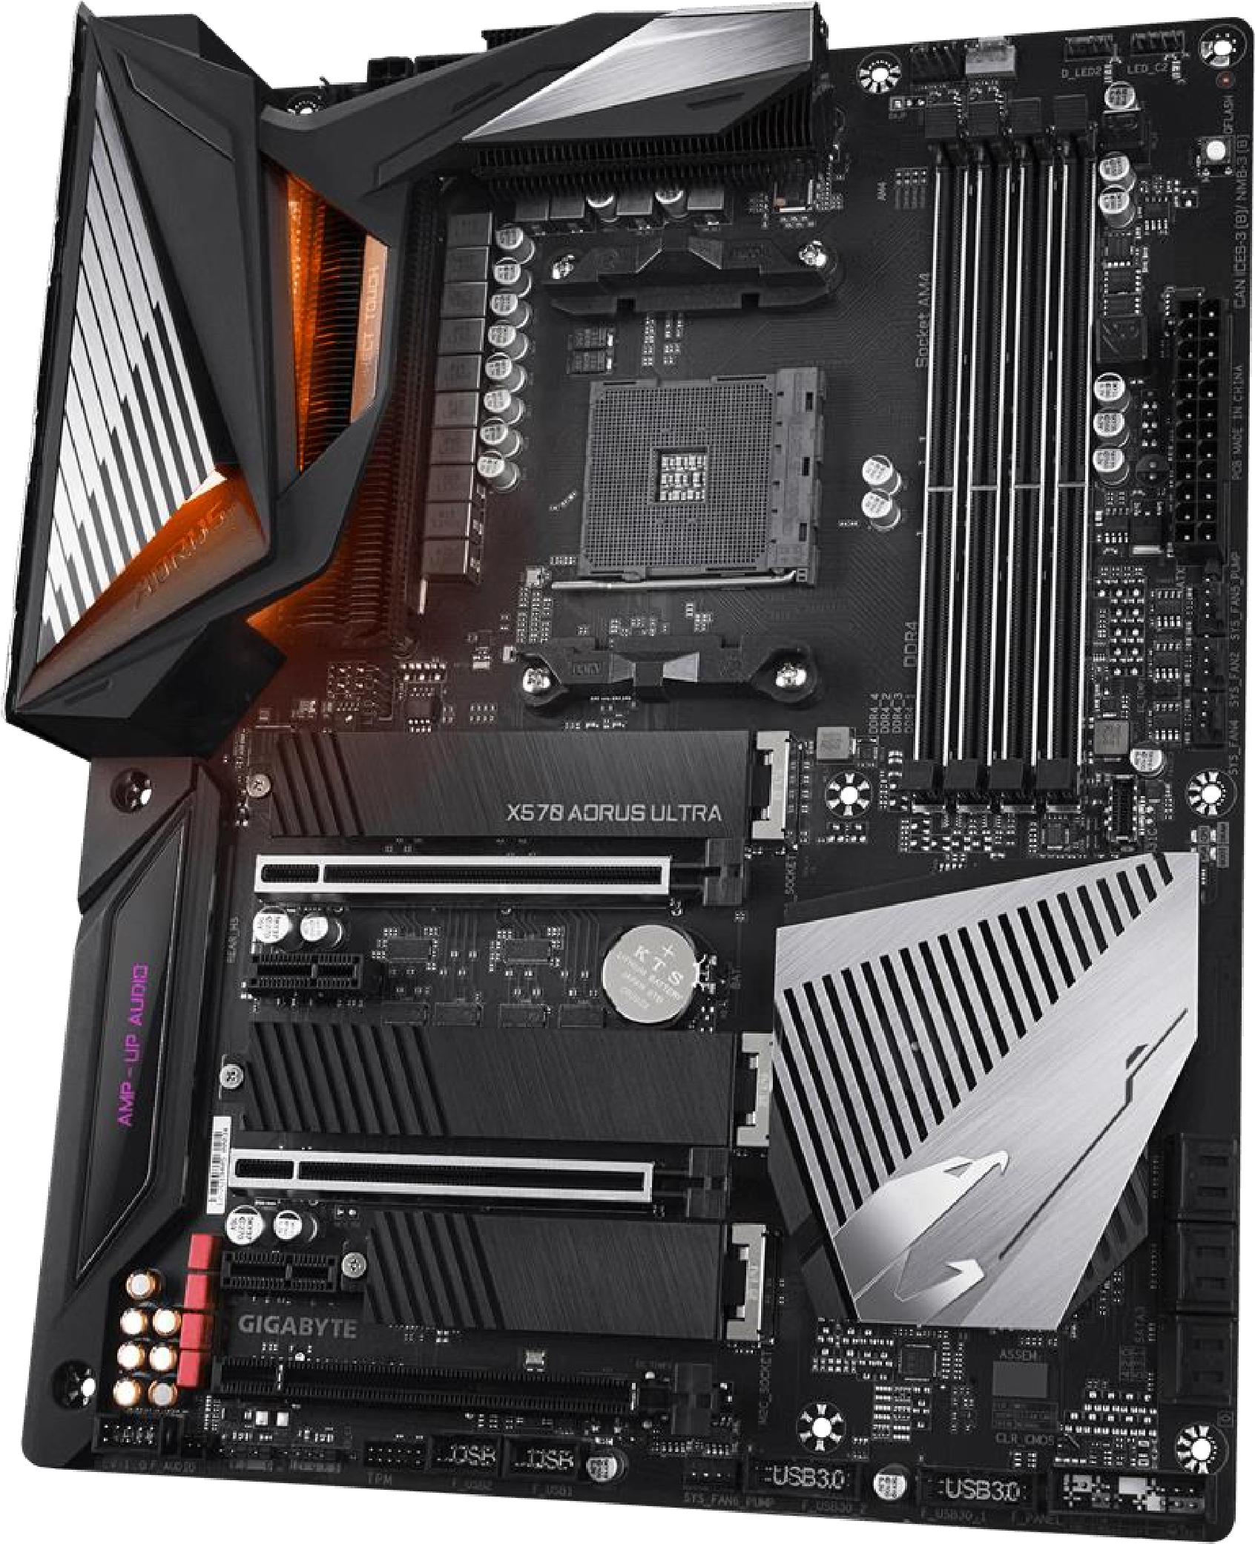

EXPLAIN

What is Motherboard?



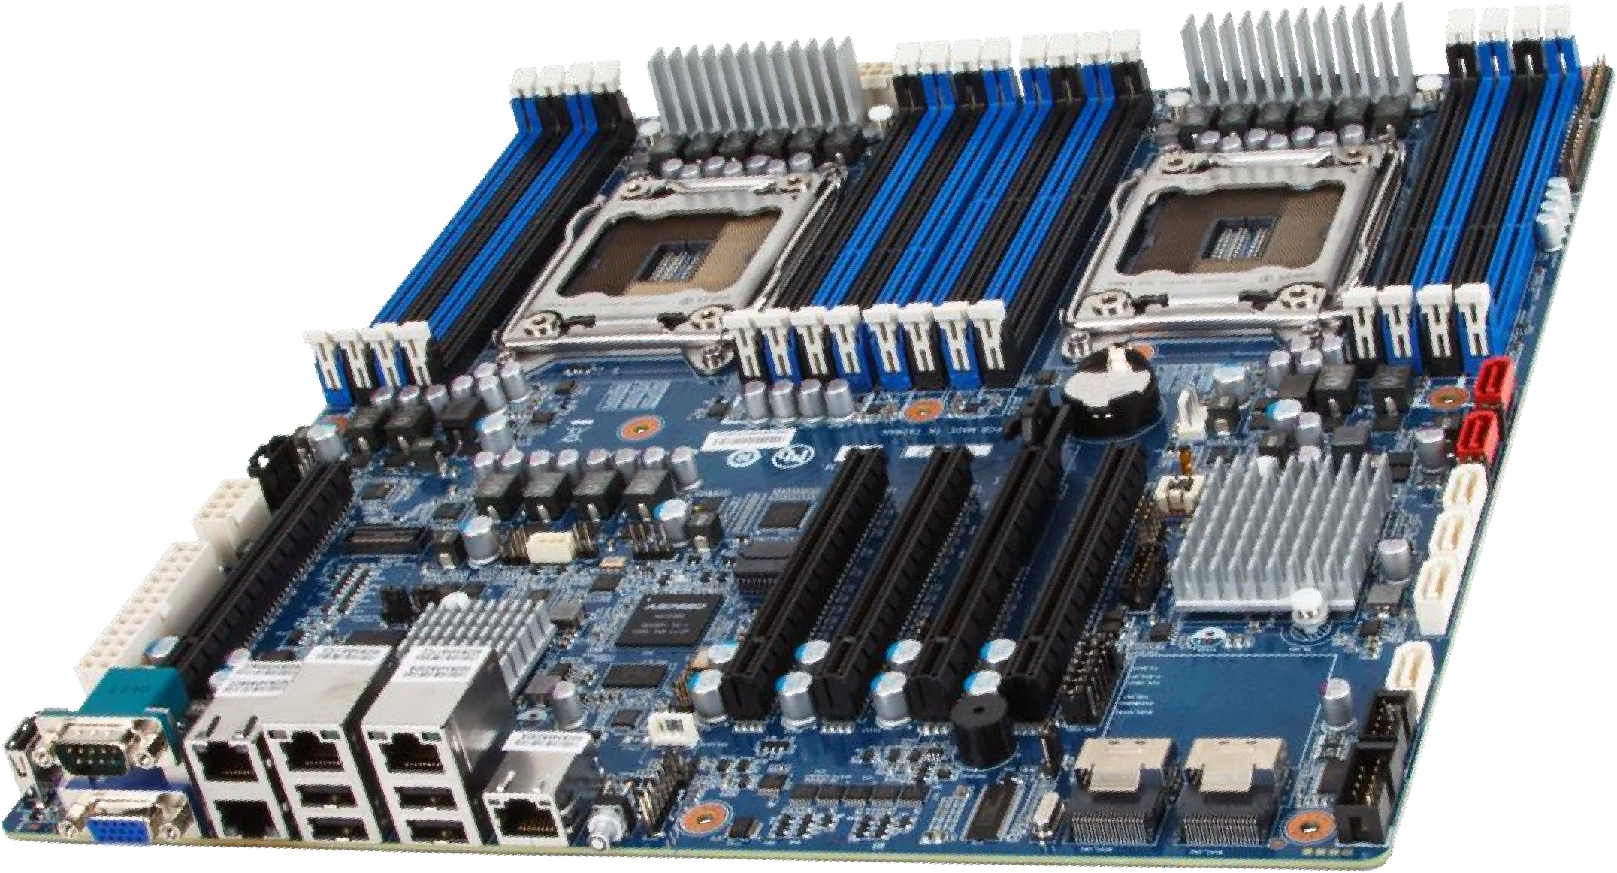10 MIN

* The motherboard is the most important part of a PC that *enables the integration and control* of all other components and devices in a complete computer system.
* Motherboard or Mainboard or System Board.

EXPLAIN

# Motherboard in short



10

MIN



Motherboard is a

**Circuit Board**

It’s a

**Backbone**

of the computer

It

**integrates**

all Hardware into one system

Allow all components to

**receive power**

and

**communicate**

together



|  |
| --- |
| Motherboard Components |

|  |
| --- |
| EXPLAIN |



10

MIN

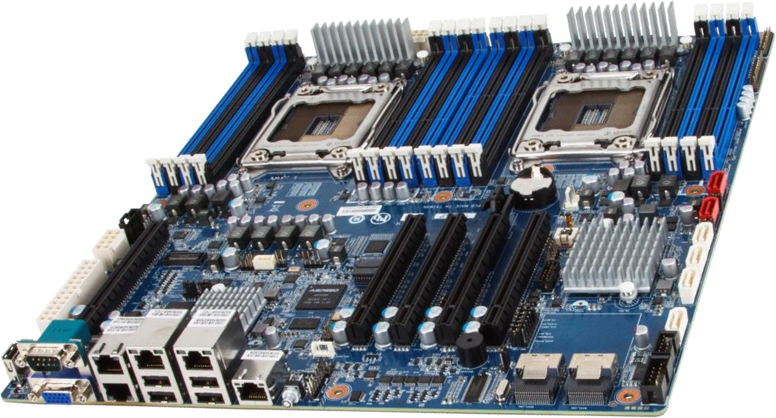

**CPU Sockets**

**RAM Slots**

**Expansion Slots**

**Port connectors**

**SATA connector**

**CMOS battery**

**Southbridge**

**Northbridge**

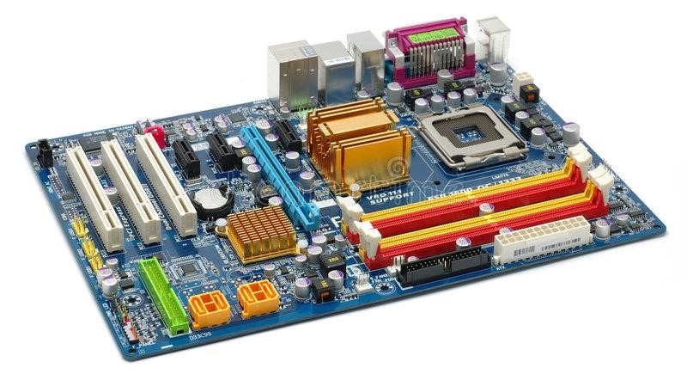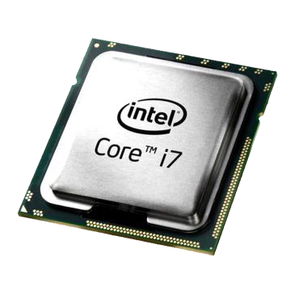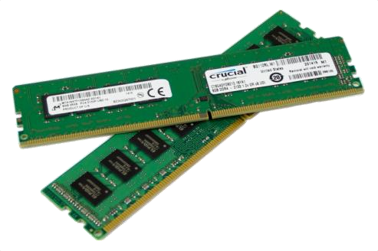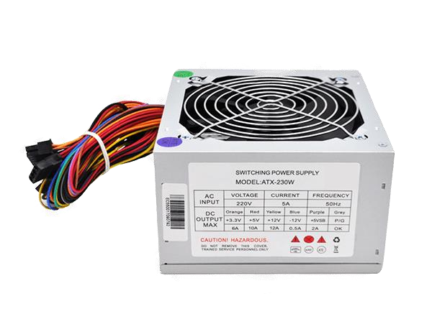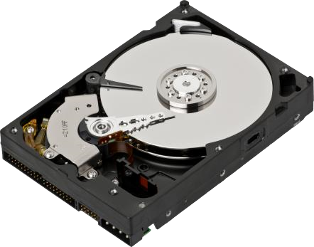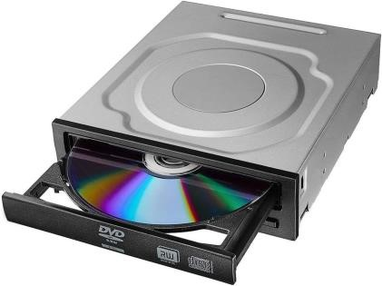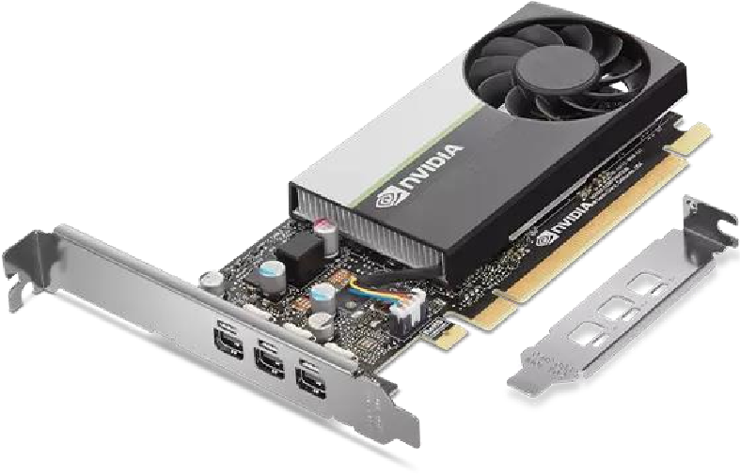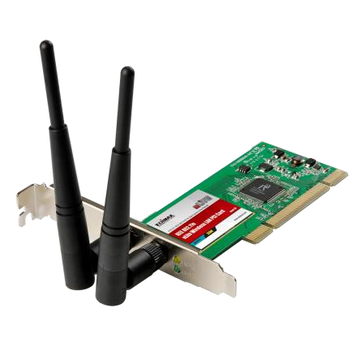

**Processor**

**(**

**CPU**

**)**

**RAM**

**Power**

**Supply**

**DVD**

**ROM**

**Hard Disk**

**Wireless**

**Card**

**Video/VGA**

**Card**



[WATCH & THIN](https://www.youtube.com/watch?v=HB4I2CgkcCo)

[K](https://www.youtube.com/watch?v=HB4I2CgkcCo)



[10](https://www.youtube.com/watch?v=HB4I2CgkcCo)

[MI](https://www.youtube.com/watch?v=HB4I2CgkcCo)

[N](https://www.youtube.com/watch?v=HB4I2CgkcCo)

[Watch the video to understand](https://www.youtube.com/watch?v=HB4I2CgkcCo)

[**the compo**](https://www.youtube.com/watch?v=HB4I2CgkcCo)

**nent of**

[**Motherboar**](https://www.youtube.com/watch?v=HB4I2CgkcCo)

[**d**](https://www.youtube.com/watch?v=HB4I2CgkcCo)

EXPLAIN

**Type of Motherboard**



10

MIN

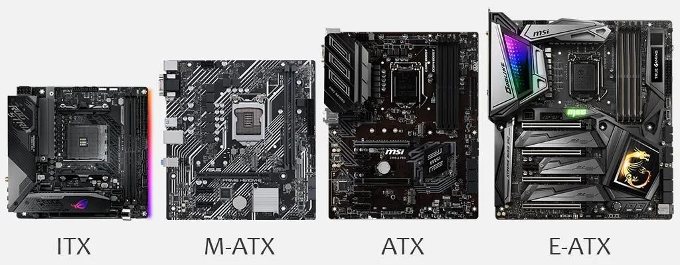

**(6.7”x6.7”) (9.6”x9.6”) (12”x9.6”) (12”x13”)**



**CPU**

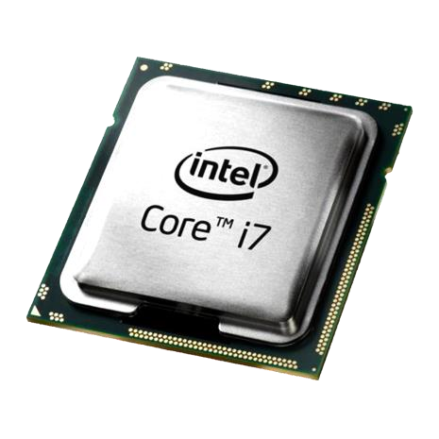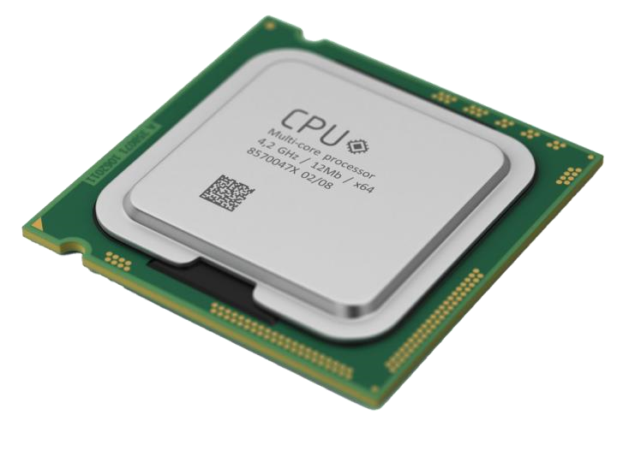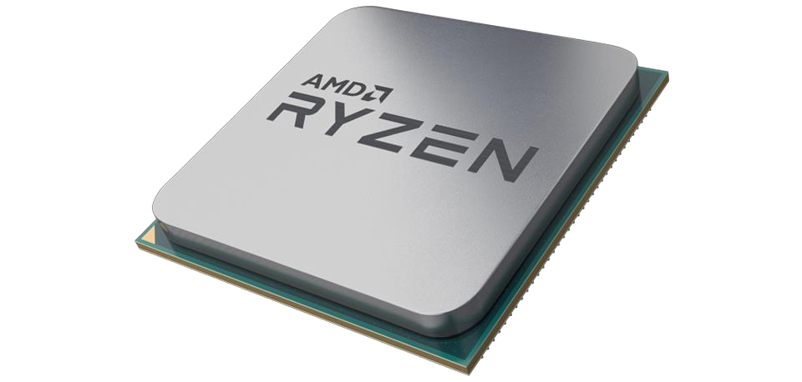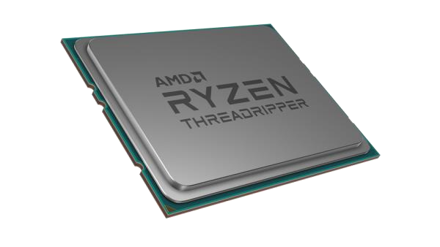

ENGAGE  **WHAT IS CPU?**

2 MIN

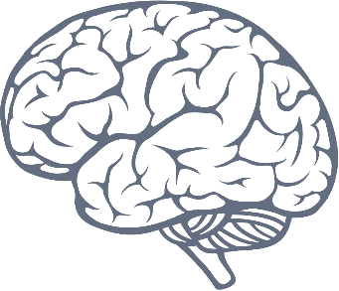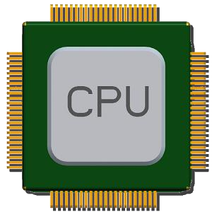

# SAME AS

ENGAGE

**What Role Of CPU In Computer?**



2

MIN



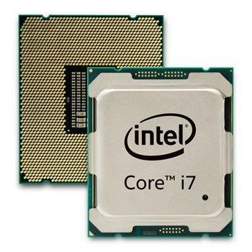What do you think

CPU dose in Computer?

It does all decisions, calculations all processing in Computer.

**Example**, even you typing or you move your mouse, all process need CPU make decisions.

**CPU in short**

10 MIN

CPU is the “

**brain**

”of Computer system

Basically the **faster the CPU**, the **faster computer** will perform

CPU stands for

**Central Processing Unit**



It

**runs**

program instructions

**MODERN CPUS**

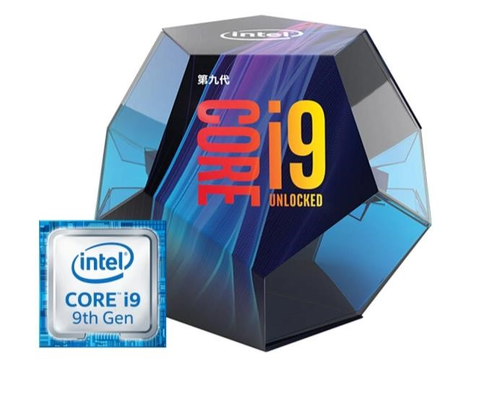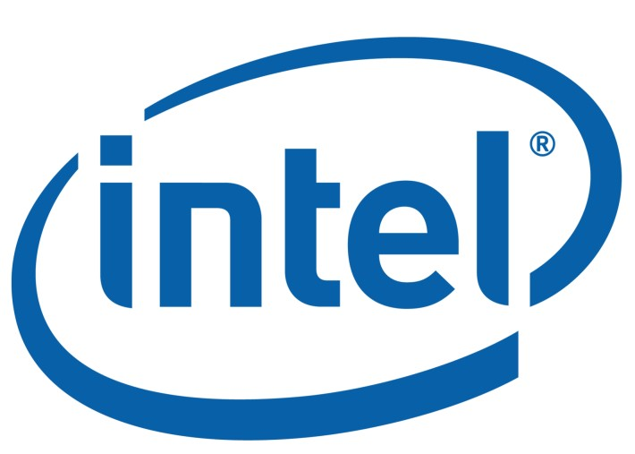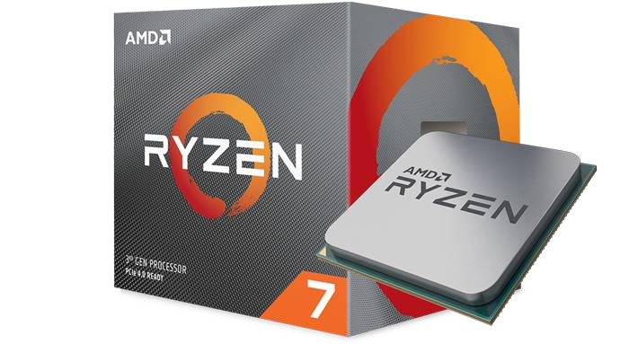

**CPU AND SOCKET**

5 MIN

|  |
| --- |
| **Manufacturers** |

## IntelAMD

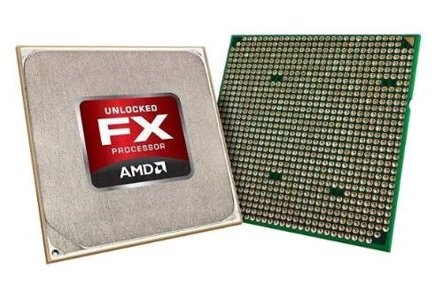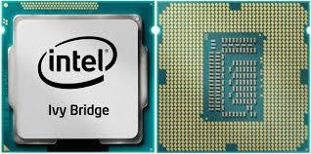

Intel platform use **LGA** ( Land grid Array) socket type.

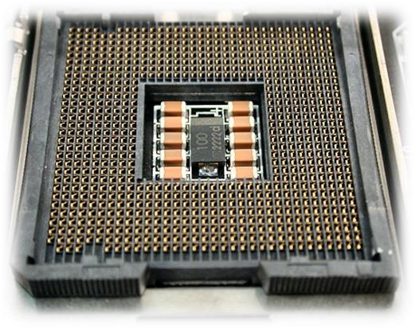

AMD platform use **PGA** ( Pin grid Array) socket type.

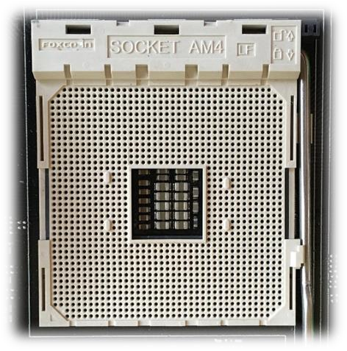

|  |  |  |
| --- | --- | --- |
| **Gaming** | **Content Creation** | **Basic Tasks** |
| Intel Core X-Series Processor | Intel Core X-Series Processor | Intel Core i3 Processor |
| Intel Core i7 Processor | Intel Core i7 Processor | Intel Core i5 Processor |
| Intel Core i9 Processor | Intel Core i9 Processor | Intel Pentium Processor |
|  |  | Intel Celeron Processor |

# TECHNOLOGY ON CPU



10

MIN



* 64-bit processing
* Virtualization support
* CPU Cores
* Integrated graphics processing unit (GPU)
* Clock speed

**SELECTING CPU**



21

**Check motherboard Manufacturers**

**Go To Manufacturers**

**Websites**

**Check spec and CPU support**



